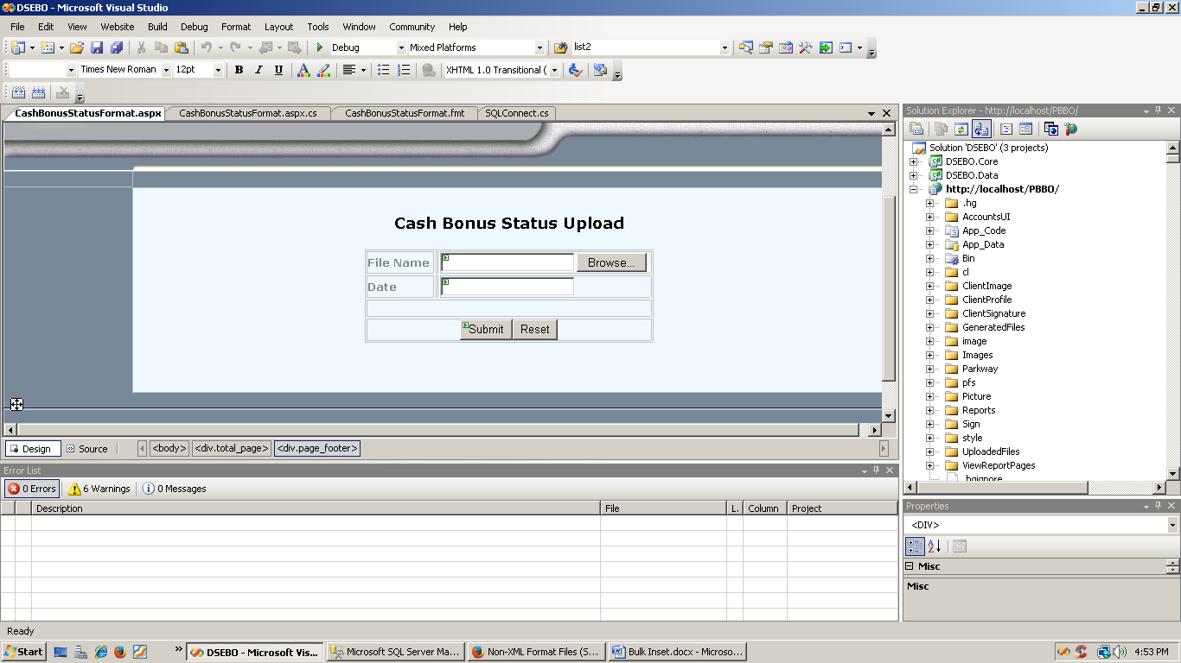

<%@ Page Language="C#" AutoEventWireup="true" CodeFile="CashBonusStatusFormat.aspx.cs" Inherits="CashBonusStatusFormat" %>

<!DOCTYPE html PUBLIC "-//W3C//DTD XHTML 1.0 Transitional//EN" "http://www.w3.org/TR/xhtml1/DTD/xhtml1-transitional.dtd">

<html xmlns="http://www.w3.org/1999/xhtml" >

<head runat="server">

<title>Cash Bonus Status Format</title>

<link type="text/css" rel="stylesheet" href="style/dse.css" />

<script type="text/javascript" src="style/c_config.js"></script>

<script type="text/javascript" src="style/c_smartmenus.js"></script>

</head>

<body style="font-size: 12pt">

<div class="total_page">

<div class="page_header"><span id="spnHeader" runat="server"><%Response.Write(DSEBO.Core.Util.getPageHeader(Session["usergroup"].ToString() + ";" + Session["username"].ToString() +";"+ this.ToString()));%></span>

</div>

<div class="page_main">

<div class="clearer"></div>

<div class="page_menu">

<%try{Response.Write(Session["Menu"].ToString());}catch (Exception exp){ Response.Redirect("Default.aspx"); }%>

</div>

<div class="page_content" style="text-align: center">

<div class="" style="MARGIN-TOP: 30px; FONT-WEIGHT: bold; COLOR: black; FONT-STYLE: normal; FONT-FAMILY: Verdana; text-align: center;">

<span style="font-size: large">Cash Bonus Status Upload</span></div>

<form id="form1" runat="server">

<table border="0" style="margin-top: 20px; margin-bottom: 20px; font-family: Verdana; text-align: right;font-size: 12pt;">

<tr>

<td style="width: 76px; height: 21px; font-weight: bold; color: #758a85; font-size: small; font-family: Verdana;" align="left">

<span style="font-size: 10pt">File Name</span></td>

<td style="height: 21px; font-family: Verdana;">

</td>

<td style="width: 243px; height: 21px; font-family: Verdana; text-align: left;">

<asp:FileUpload ID="fileUpload" runat="server" /></td>

</tr>

<tr>

<td align="left" style="font-weight: bold; font-size: small; width: 76px; color: #758a85;

font-family: Verdana; height: 21px">

Date</td>

<td style="font-family: Verdana; height: 21px">

</td>

<td style="width: 243px; font-family: Verdana; height: 21px; text-align: left">

<asp:TextBox ID="txtDate" runat="server"></asp:TextBox></td>

</tr>

<tr style="font-family: Verdana">

<td colspan="3" style="text-align: center">

</td>

</tr>

<tr style="font-family: Verdana">

<td colspan="4" style="text-align: center; width: 330px;">

<asp:Button ID="button_submit" Text="Submit" runat="server" OnClick="button_submit_Click" /><input type="reset" id="button_reset" name="cmdReset"/></td>

</tr>

</table>

<br />

</form>

</div>

<div class="clearer"></div>

</div>

<div class="page_footer" style="text-align: center">

</div>

</div>

</body>

</html>

using System.Collections;

using System.Web;

using System.Web.Security;

using System.Web.UI;

using System.Web.UI.WebControls;

using System.Web.UI.WebControls.WebParts;

using System.Web.UI.HtmlControls;

using System.IO;

using DSEBO.Core;

using System.Web.Configuration;

using ElementIT.PowUpload;

public partial class CashBonusStatusFormat : System.Web.UI.Page

{

string msg;

protected void Page_Load(object sender, System.EventArgs e)

{

if (!IsPostBack)

{

string prevUrl = null;

string userGroup = Session["usergroup"].ToString();

if (Request.QueryString["prevurl"] != null)

prevUrl = Request.QueryString["prevurl"].ToString();

string currentUrl = System.Web.HttpContext.Current.Request.Url.ToString();

string prevLink = Util.GetPageLink(prevUrl);

string currentLink = Util.GetPageLink(currentUrl);

if (!Util.CheckUserAccess(userGroup, currentLink, prevLink))

{

Response.Redirect("Error.aspx");

}

}

}

protected void button_submit_Click(object sender, System.EventArgs e)

{

PowUpload UploadResult = new PowUpload();

StreamReader sr = new StreamReader(UploadResult.Files[0].InputStream);

StreamWriter sw = new StreamWriter(Server.MapPath("CashBonusStatusData.txt"));

sw.Write(sr.ReadToEnd());

sw.Close();

sr.Close();

//sr = new StreamReader(Server.MapPath("NewClientChargeFormat.fmt"));

//sw = new StreamWriter(Server.MapPath("NewClientChargeFormat.fmt"));

//sw.Write(sr.ReadToEnd());

//sw.Close();

//sr.Close();

string fileName = Server.MapPath("CashBonusStatusData.txt");

string formatFile = Server.MapPath("CashBonusStatusFormat.fmt");

ArrayList errors = new ArrayList();

SQLConnect sqc = new SQLConnect(SQLConnect.DBConnectionInfo());

//// ///////////Audit Trail Entry on CALL procedure

//AuditTrailServer.AddAuditInfo(Session["usergroup"].ToString(), Session["username"].ToString(),

//this.Request.Url.ToString() + "(" + Util.GetUserPcName(Request.UserHostAddress) + ")", "",

//"SQLConnect.CallProcessClearingAccountStatusFormat", "FormParameter:txtDate,fileupload", "",

//"FileName:" + UploadResult.Files[0].ClientFilePath,

//"Execute Process Clearing Account Status Format", DateTime.Now);

////////////////

msg = sqc.CallProcessCashBonusStatusFormat(fileName, formatFile, Util.getDate(this.txtDate.Text));

MessageBox.Show(msg);

}

}

string fileName = Server.MapPath("CashBonusStatusData.txt");

string formatFile = Server.MapPath("CashBonusStatusFormat.fmt");

ArrayList errors = new ArrayList();

SQLConnect sqc = new SQLConnect(SQLConnect.DBConnectionInfo());

//// ///////////Audit Trail Entry on CALL procedure

//AuditTrailServer.AddAuditInfo(Session["usergroup"].ToString(), Session["username"].ToString(),

//this.Request.Url.ToString() + "(" + Util.GetUserPcName(Request.UserHostAddress) + ")", "",

//"SQLConnect.CallProcessClearingAccountStatusFormat", "FormParameter:txtDate,fileupload", "",

//"FileName:" + UploadResult.Files[0].ClientFilePath,

//"Execute Process Clearing Account Status Format", DateTime.Now);

////////////////

msg = sqc.CallProcessCashBonusStatusFormat(fileName, formatFile, Util.getDate(this.txtDate.Text));

MessageBox.Show(msg);

}

}

using System;

using System.Collections.Generic;

using System.Collections;

using System.Text;

using System.Data.SqlClient;

using System.Data;

using System.Web.Configuration;

using System.Configuration;

namespace DSEBO.Core

{

public class SQLConnect

{

/..................... saif...................................//

public string CallProcessCashBonusStatusFormat(string filename, string formatfile, DateTime date)

{

SqlParameter errorMsg = new SqlParameter("@errmsg", SqlDbType.VarChar, 1000);

errorMsg.Direction = ParameterDirection.Output;

try

{

this.command.CommandText = "CashBonusStatusFormat";

this.command.CommandType = CommandType.StoredProcedure;

this.command.Parameters.Add("@filename", SqlDbType.VarChar, 1000).Value = filename;

this.command.Parameters.Add("@formatfile", SqlDbType.VarChar, 1000).Value = formatfile;

this.command.Parameters.Add("@date", SqlDbType.DateTime).Value = date;

this.command.Parameters.Add(errorMsg);

this.command.ExecuteNonQuery();

return errorMsg.Value.ToString();

}

catch (Exception e)

{

Console.Write(e);

return errorMsg.Value.ToString();

}

}

//...............................................................//

}

}

GO

/****** Object: Table [dbo].[CashBonusStatus] Script Date: 07/28/2015 15:50:19 ******/

SET ANSI_NULLS ON

GO

SET QUOTED_IDENTIFIER ON

GO

SET ANSI_PADDING ON

GO

CREATE TABLE [dbo].[CashBonusStatus](

[ISIN] [varchar](50) NOT NULL,

[ISINShortName] [varchar](100) NOT NULL,

[SequenceNo] [int] NOT NULL,

[CAType] [varchar](50) NOT NULL,

[RecordDate] [varchar](100) NOT NULL,

[EffectiveDate] [varchar](100) NOT NULL,

[CashFractionAmount] [float] NOT NULL,

[PaymentDate] [varchar](50) NOT NULL,

[BOID] [varchar](20) NOT NULL,

[BOShortName] [varchar](50) NOT NULL,

[BOType] [varchar](50) NOT NULL,

[BOCategory] [varchar](50) NOT NULL,

[BONationality] [varchar](50) NOT NULL,

[BOResidency] [varchar](50) NOT NULL,

[GrossCashEntitlement] [float] NOT NULL,

[TaxAmount] [float] NOT NULL,

[NetCashEntitlement] [float] NOT NULL,

[BOHoldings] [float] NOT NULL,

[RecordDate2] [varchar](100) NOT NULL,

[Date] [datetime] NULL

) ON [PRIMARY]

GO

SET ANSI_PADDING OFF

GO

/****** Object: StoredProcedure [dbo].[CashBonusStatusFormat] Script Date: 07/28/2015 13:25:09 ******/

SET ANSI_NULLS ON

GO

SET QUOTED_IDENTIFIER ON

GO

create Procedure [dbo].[CashBonusStatusFormat]

(

@filename varchar(1000),

@formatfile varchar(1000),

@date datetime,

@errmsg as varchar(1000) output

)

AS

set @errmsg = ''

declare @query nvarchar(300)

begin transaction

TRUNCATE TABLE CashBonusStatus

set @query='BULK INSERT CashBonusStatus FROM ''' + @filename + ''' WITH (FORMATFILE = ''' + @formatfile + ''')'

EXECUTE sp_executesql @query

if @@ERROR<>0

set @errmsg = 'Error in Bulk Inserting into Cash Bonus Table'

else

update CashBonusStatus SET Date=@date

if @errmsg <> ''

begin

rollback

end

else

begin

set @errmsg= @errmsg+'File upload is successfull.'

commit

end

RETURN